CHEMISTRY UNIT 1 & 2 ASSIGNMENT #2
The format for this assignment will be an in-class written response to two questions. The two questions you will be asked will be selected from the following list. The questions will be chosen by your teacher and you will not know which questions will be asked prior to the in-class test. This means you will need to prepare for all four possible questions.

During your 1 hour response you should devote roughly equal time to both responses. When preparing your answers, make sure you can handwrite your answers in less than 30 minutes time.

Question #1
‘The shape of molecules can be determined using VSEPR theory. This information, combined with an understanding of electronegativity and symmetry, can be used to explain the polarity of molecules.’

Elaborate on the ideas provided in this passage. Your answer should demonstrate a thorough understanding of:
- VSEPR theory and its application
- The relationship between electronegativity, symmetry and polarity of molecules

Your answer should include a range of examples, including polar and non-polar molecules, and use diagrams where relevant.

Question #2
The physical properties of covalent molecular substances, including melting and boiling points, are influenced by the types and strength of intermolecular forces. The effects of these forces can be seen in the boiling point trends for hydrides in Group 14, 15, 16 and 17.

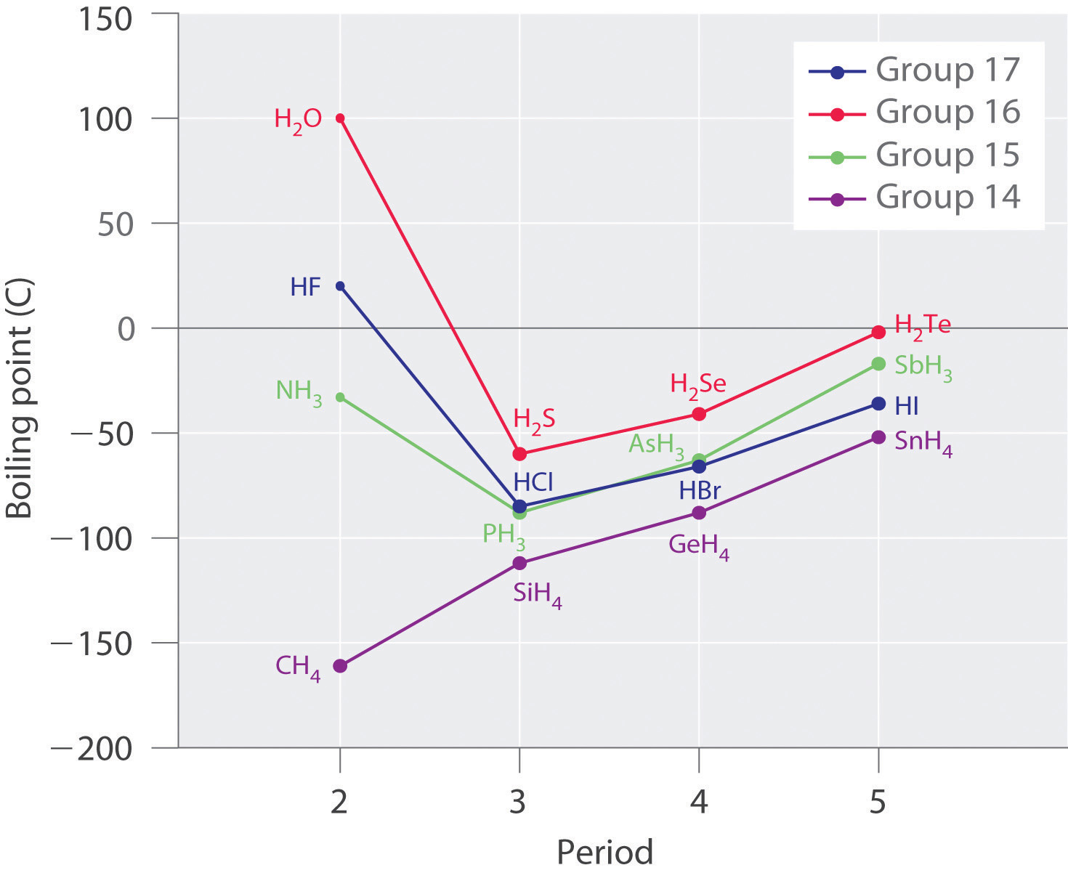

Describe the origin and nature of dispersion forces, dipole-dipole forces and hydrogen bonding, and use these concepts to explain the trends in boiling points for hydrides in Group 14-17.

Your answer should include diagrams where relevant.

Question #3

Chromatographic techniques, including thin layer chromatography (TLC), gas chromatography (GC), and high performance liquid chromatography (HPLC), are used to determine the components of a wide range of mixtures in various settings.

For each of the above instruments:
- Explain how separation of components is achieved
- Explain how data from each technique can be used to determine the composition and purity of substances

Your answer should include diagrams where relevant.

Question #4:

The following table gives information about the solubility of some solutes in the solvents water and hexane.

Solute | Solvent
 | Water | Hexane
decane | insoluble | soluble
methanol * | soluble | slightly soluble
pentan-1-ol * | slightly soluble | soluble
allose * | soluble | insoluble
sodium chloride | soluble | insoluble
silver chloride | insoluble | insoluble

Discuss the intermolecular and interionic forces involved in the above solutes and solvent, and so account for the solubility of each substance in water and hexane.

* The structures of selected organic substances are shown below:
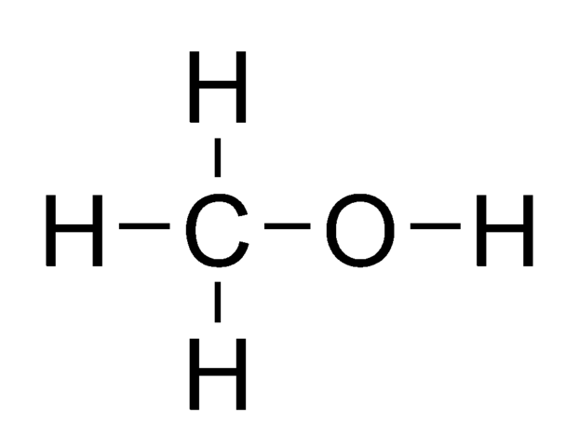 | 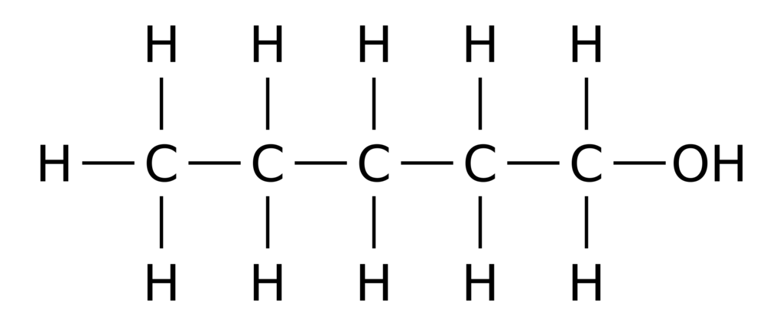 | 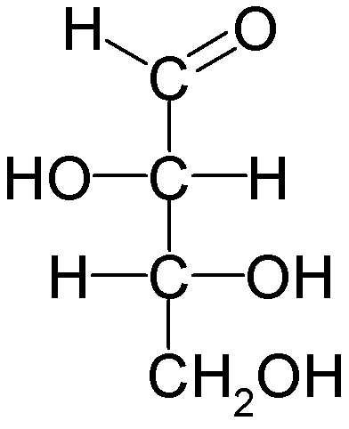
Methanol | Pentan-1-ol | Allose

By the end of the Term 2 holidays you should have planned your answers to Questions 1 to 4. On the second lesson back of Term 3 you will need to submit handwritten drafts for Questions 1 to 4. Include on your draft the amount of time (minutes) it took to physically write out each answer. Your teacher will briefly skim your answer to ensure you have addressed the main points of the question.

The drafts themselves are not marked. 100% of the mark comes from your in-class written response part way through Term 3. However, if you fail to submit drafts on time, or if you submit drafts which are incomplete, then marks will be deducted from your in-class response.

